**MySQL Installer 8.0.18**

Go to this link : <https://dev.mysql.com/downloads/windows/installer/8.0.html>

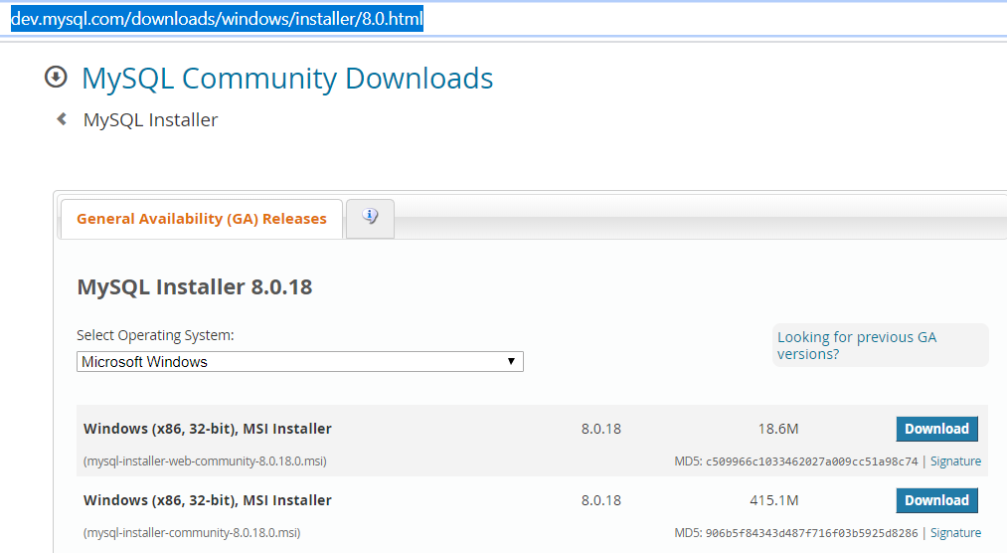

Notice that there is no 64-bit installer. That’s ok. We will use the 32-bit installer, the (mysql-installer-community-8.0.21.0.msi) (Highlighted in figure below)

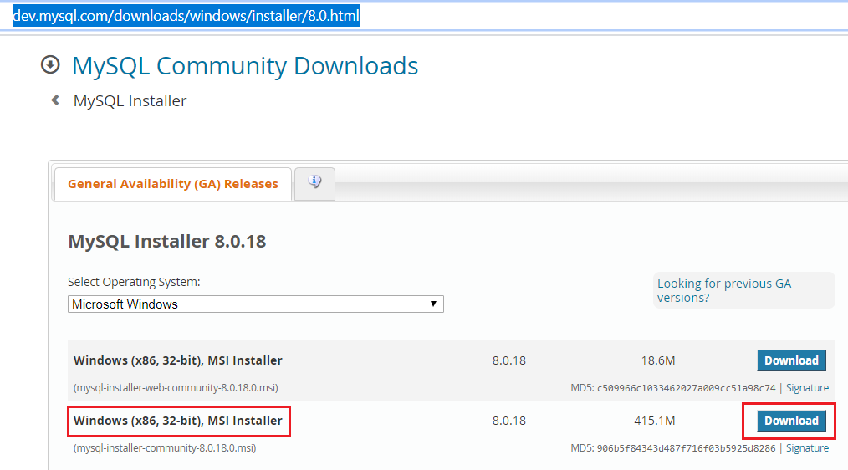

You need not sign up in next screen. But if you have an Oracle account, you may. You will get this screen where you will download the msi file.

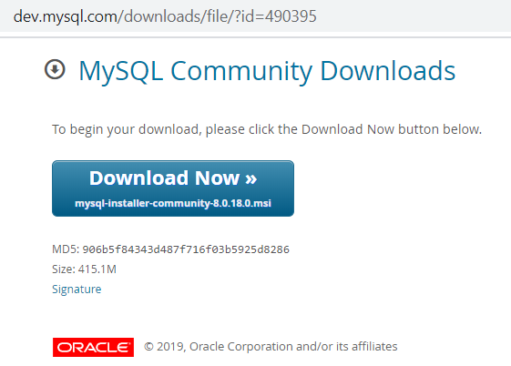

After downloading, run the msi file.

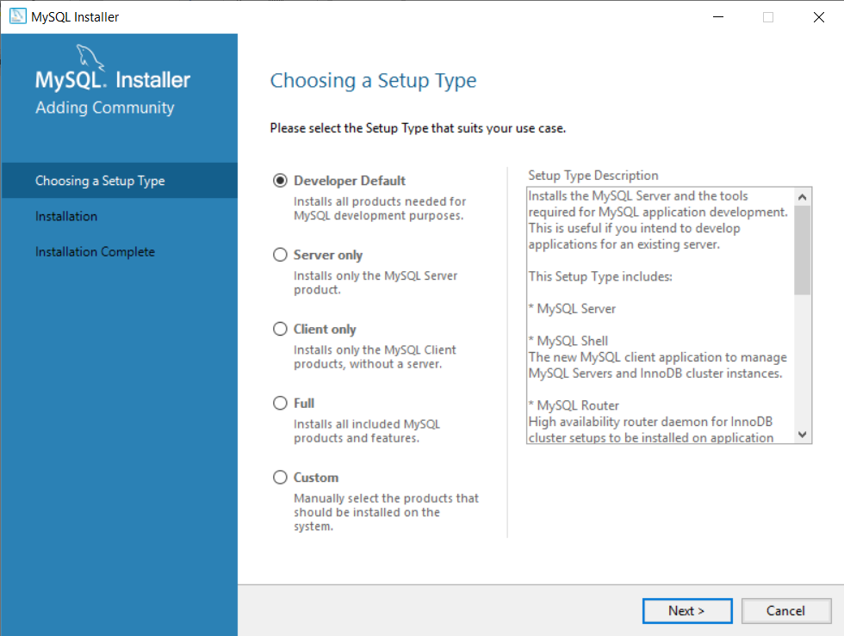

The Developer default option will install everything, including workbench, server etc. But we will choose the **custom** option:

Select the following options and push them into RHS pane.

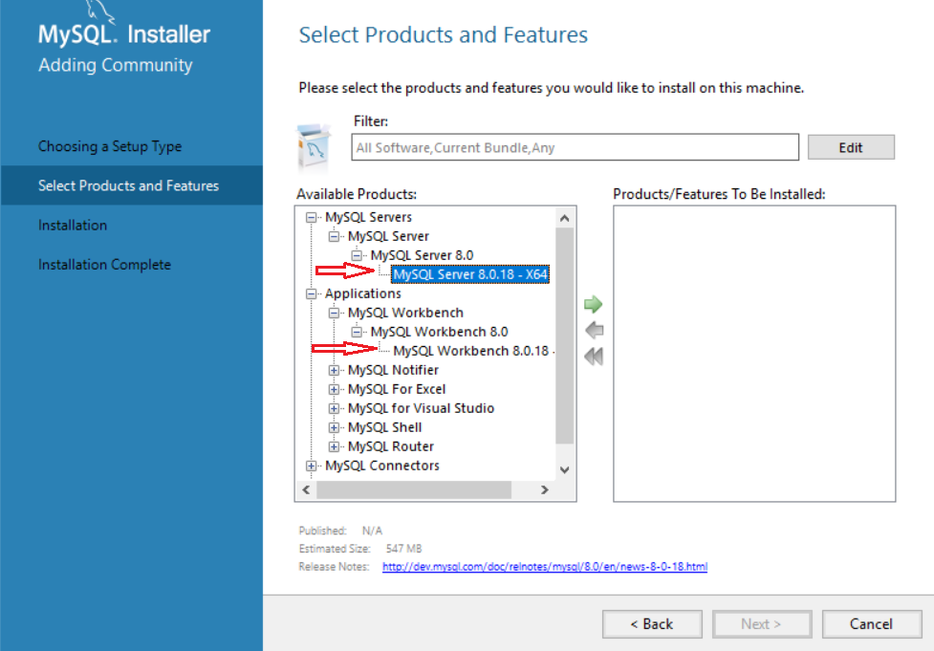

So finally, these are my 4 choices: Make sure your Right Hand Pane has these 4 options.

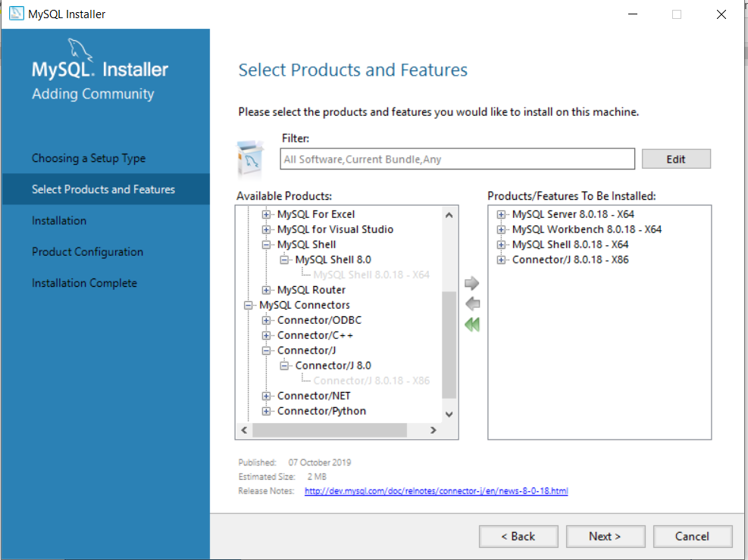

Click on next and execute to install the packages. Typically installs in:

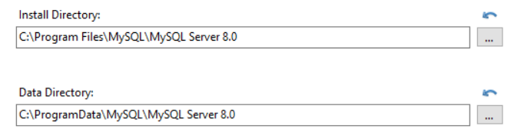

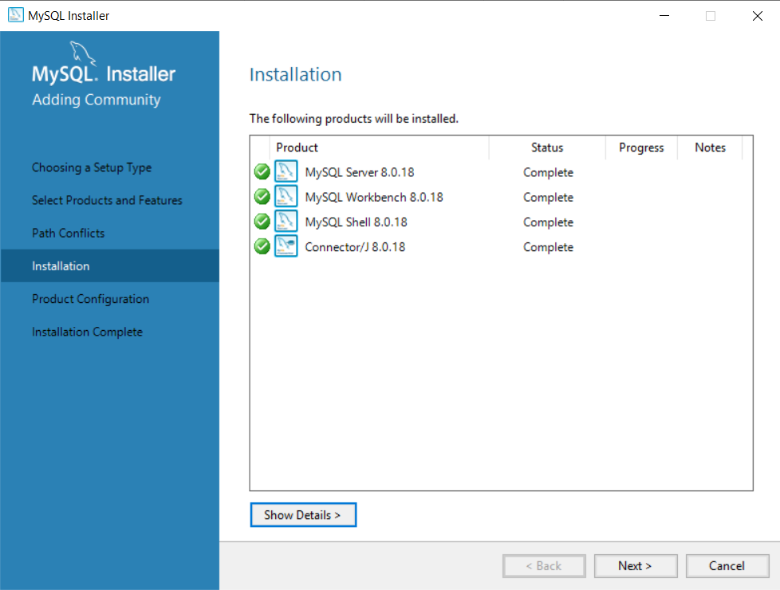

Click on next for configuring product:

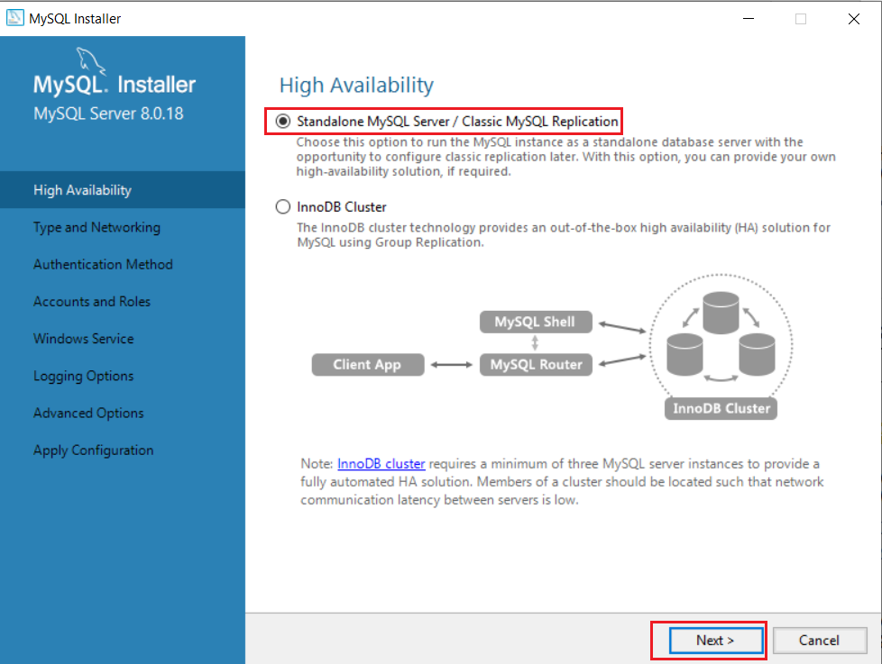

Select highlighted portions in above figure. No change required in next screen, just click “next”

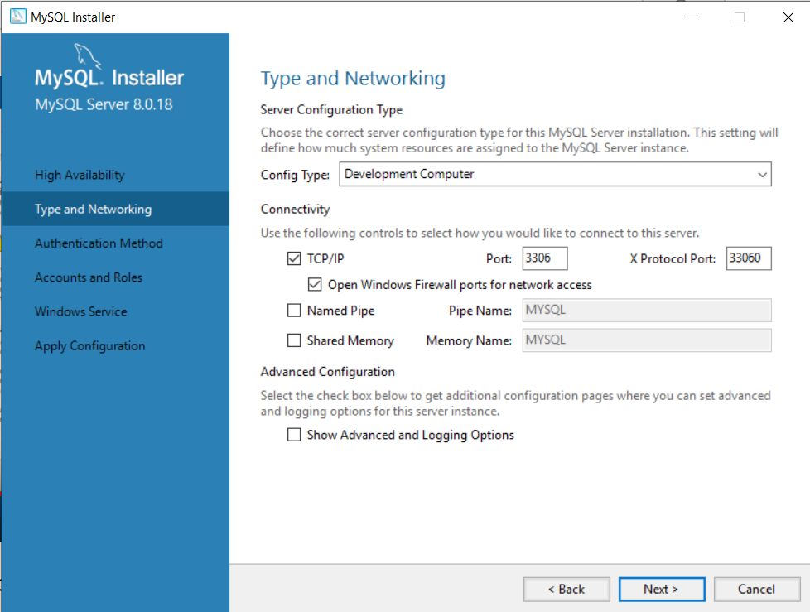

Use first option and click next:

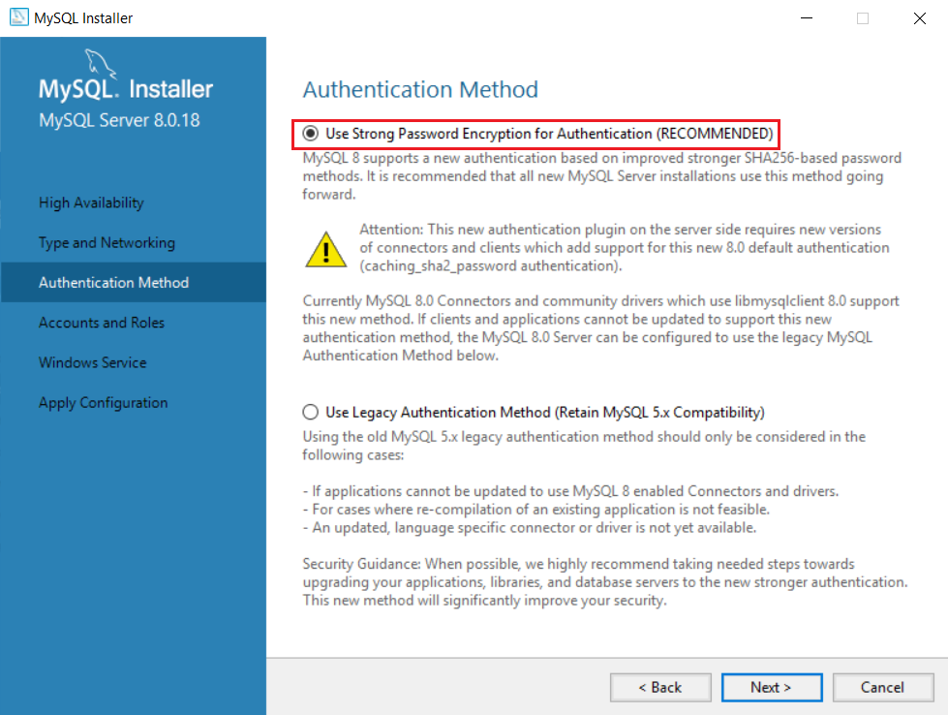

**I set the password as root123. You can give any password you want, just make sure you will remember it**

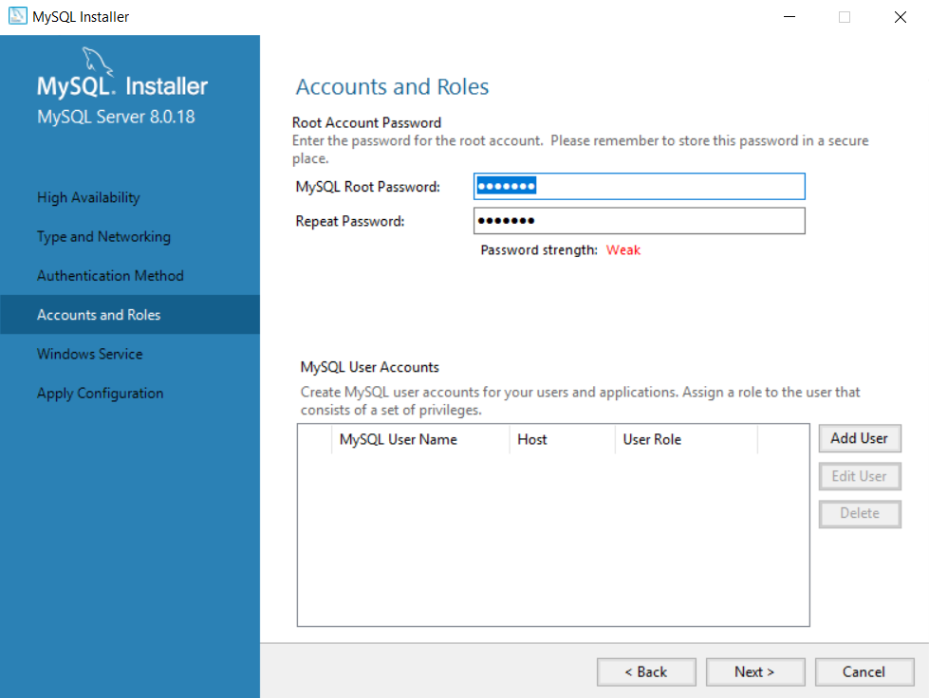

The remaining screens are as is. On last screen, simply click execute button:

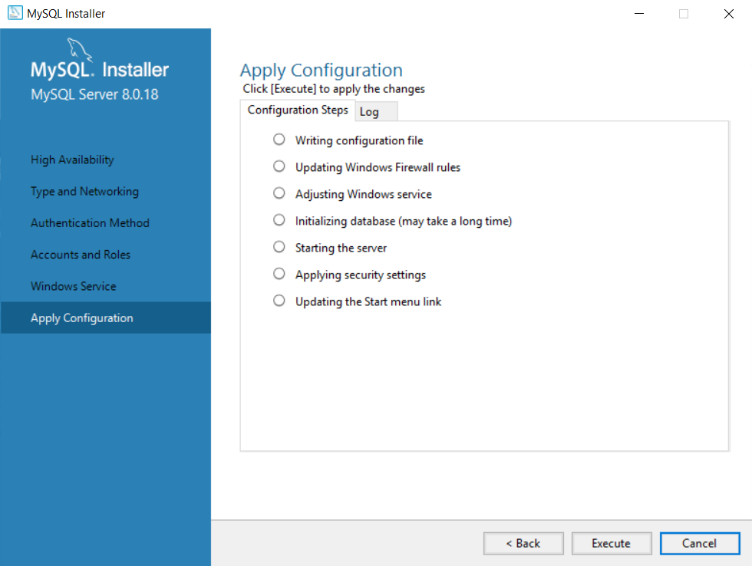

After clicking on Finish, the Workbench starts automatically. But we will use command line client to work with MySQL, not the GUI workbench

I started mysql command prompt to begin working by going to :

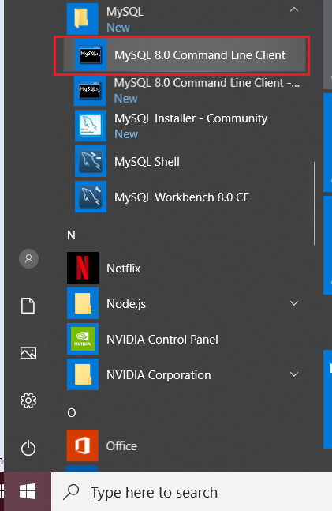

You get this : Password will be whatever you set earlier

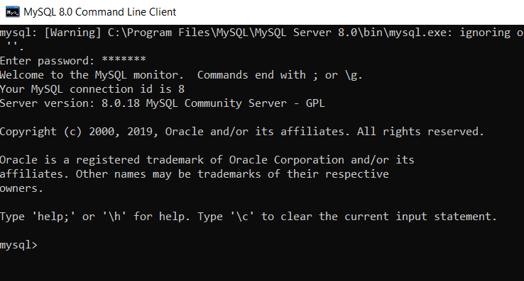

To see all the databases you have on your system:

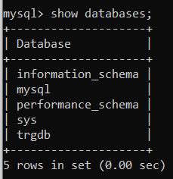

To create your own database:

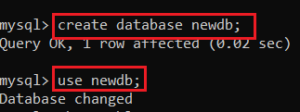

To connect to your database:

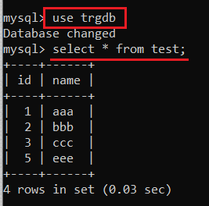

To see all tables in your database:

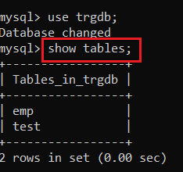

To create table, insert rows etc:

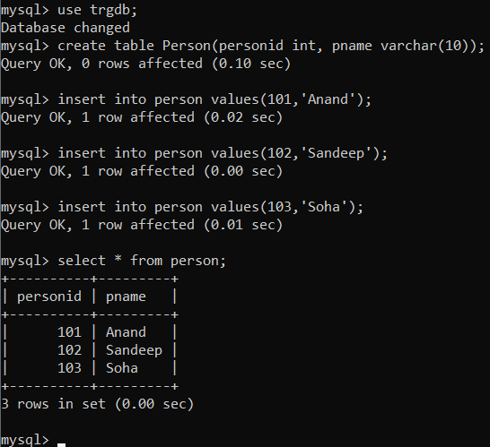

**How to use in a Java app?**

Google for and download mysql-connector-java-8.0.18.jar. you can download from <https://jar-download.com/artifacts/mysql/mysql-connector-java/8.0.18/source-code>

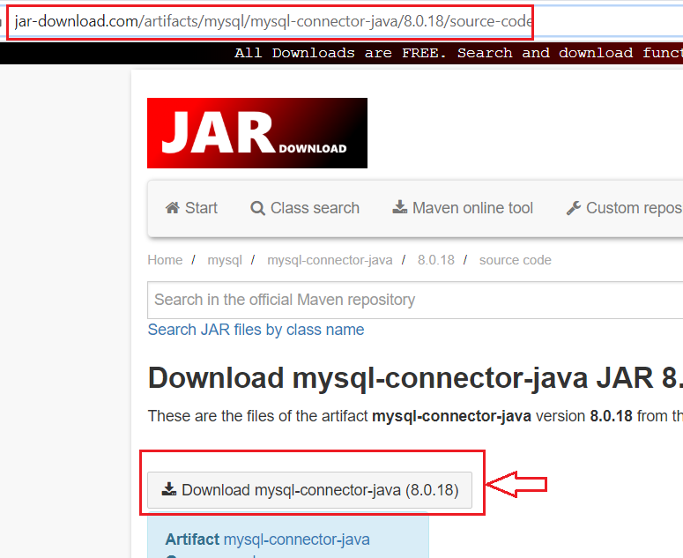

Bring this jar into your classpath ( I will show you how to in class session)

Specify this in your java app:

**public** **static** **void** main(String[] args) {

String url = "jdbc:mysql://localhost:3306/trgdb";

**try** {

DriverManager.*registerDriver*(**new** com.mysql.cj.jdbc.Driver());

Connection conn = DriverManager.*getConnection* (url, "root", "root123");